 Invention Disclosure Format (IDF)-B | Document No. | 02-IPR-R003
 | Issue No/Date | 2/01.02.2024
 | Amd. No/Date | 0/00.00.0000

Title of the invention:

Self-Powered Intelligent Pedestrian Protection System Using Dynamic Safety Barrier and Energy Harvesting Zebra Crossing

Field /Area of invention:

- Field of Invention: Embedded Systems, Intelligent Transportation Systems, Smart Traffic Management Systems.
- Focus of Invention: The invention aims at ensuring improved safety for pedestrians at zebra crossings. This is achieved through the development of an intelligent system capable of detecting pedestrians and operating a physical safety barrier to prevent vehicles from entering the crossing area during the time of pedestrian movement.
- Core Technology of Invention: The invention is based on microcontroller automation using Arduino. The invention also employs several sensors, including ultrasonic sensors, infrared sensors, light sensors using LDR, sound sensors, and limit switches. The invention also employs piezoelectric-based energy harvesting technology, actuator-based barriers, buzzers, and LCD displays.
- Integration: The invention is based on the integration of several features, including pedestrian detection, vehicle proximity detection, traffic signal detection, and emergency vehicle detection. The invention is also based on energy harvesting using mechanical pressure on the zebra crossing, which is based on piezoelectric plates. This ensures that the invention is self-powered and does not require cloud connectivity.

- Prior Patents and Publications from literature (provide a table summarizing the prior art)
  - Patent Literature

S.No | Title | Publication  Type | Summary | Gap Identified | Differentiating  Methodology
1 | Smart Pedestrian Crossing System | Patent | Describes automated pedestrian crossings where traffic lights are controlled using sensors to allow pedestrians to cross safely. | The system relies only on traffic signals and driver compliance, with no physical barrier  for pedestrian protection | The proposed invention introduces a dynamic safety barrier that physically stops vehicles during  pedestrian crossing, improving safety.
2 | Piezoelectric Road Energy Harvesting System | Patent | Describes embedding piezoelectric materials in roads to generate electricity from vehicle movement and road vibrations. | The generated energy is typically used for general lighting or grid supply and is not integrated with  pedestrian safety infrastructure. | The proposed system directly integrates piezoelectric energy harvesting with the pedestrian protection system, making the  zebra crossing self- powered.

3 | Intelligent Traffic Monitoring and Violation Detection System | Patent | Uses cameras and monitoring systems to detect traffic violations and record vehicles that break traffic rules. | These systems require external power and centralized monitoring, increasing deployment cost.. | The proposed invention is self-powered and decentralized, operating using harvested energy and embedded control.

  - Non - Patent Literature

S.No | Title | Publication Type | Summary | Gap Identified | Differentiating Methodology
1 | Smart Pedestrian Crossing Using  Sensor-Based Traffic Control | Research Paper | Uses IR sensors or cameras to detect pedestrians and adjust traffic lights accordingly to allow safe crossing. | The system relies only on traffic signal changes and does not actively stop vehicles from entering the crossing area. | The proposed system introduces a motorized safety barrier along with multi-sensor detection to physically enforce pedestrian protection.
2 | Piezoelectric Energy Harvesting for Smart Road Applications | Journal Article | Studies the generation of electrical energy from mechanical stress produced by vehicles on piezoelectric materials embedded in roads. | The research focuses mainly on energy generation and storage but does not apply the energy to real-  time pedestrian safety systems. | The invention uses harvested energy to power the barrier system, sensors, warning lights, and monitoring components.
3 | IoT-Based Smart Traffic Monitoring System | Conference Paper | Implements traffic monitoring using cameras, sensors, and internet connectivity for data analysis and traffic control. | Requires internet connectivity and cloud infrastructure, making it unsuitable for  decentralized or remote locations. | The proposed invention functions as a standalone intelligent system without cloud or internet dependency.

From the literature survey, it has been observed that various systems have been proposed to deal with different aspects such as pedestrian detection, traffic signal automation, road barriers, and energy harvesting individually. However, none of the systems have addressed the following aspects together:
- Physical protection of pedestrians through a dynamic barrier
- Self-sustaining capability through energy harvesting
- Handling of emergency vehicles through siren detection
- Decentralized and standalone embedded control
This clearly shows the research and innovation gap, which this proposed invention aims to bridge.

Summary and background of the invention (Address the gap / Novelty)

The Gap: It exists because drivers exceed speed limits and drive recklessly which creates dangerous conditions for pedestrians at zebra crossings. Drivers ignore traffic signals and fail to decrease their speed at pedestrian crossings which creates situations that lead to accidents and injuries and fatalities. Common zebra crossings depend on traffic signals and road markings and signboards to show drivers the correct way to proceed while lacking any system that would protect pedestrians from harm.
Multiple current systems work to improve pedestrian security through their use of sensor technology for traffic signal system management and their implementation of alert systems which use flashing lights and alarms. The systems depend on driver adherence to rules because they lack a system which would actively stop vehicles from driving into pedestrian crossing zones during crossing times.
Current traffic safety systems need ongoing external power sources together with centralized traffic monitoring systems for their full functionality. The systems operate in areas which lack dependable power supply or network access while their installation costs and operational expenses rise.

The Novelty: The Self-Powered Intelligent Pedestrian Protection System works to protect pedestrians through its active system which protects people crossing zebra crossings. The invention uses various sensing methods to track current traffic conditions. The sensors identify traffic signal status pedestrian presence and approaching vehicle distance and emergency vehicle siren sounds. The system utilizes these inputs to operate a motorized dynamic safety barrier which raises or lowers to control vehicle access at the crossing area.
The system introduces its main innovation through energy harvesting technology which it incorporates into zebra crossings. The crossing surface contains piezoelectric sensors which generate electrical energy from pedestrian footsteps and vehicle movement. The system operates as a self-powered energy-efficient infrastructure unit because it processes energy through its conditioning system before storing and reusing it to power its components.
The system includes visual and audible warning systems which use buzzers and an LCD countdown display to show pedestrians their remaining time to cross. Emergency vehicle detection systems enable ambulances police and fire vehicles to drive through by temporarily lowering the barrier.
The proposed invention establishes a pedestrian safety system which operates independently through decentralized technology while maintaining complete energy efficiency and intelligent functionality. The system uses sensing technology to detect emergency situations while it enforces safety rules through automated enforcement mechanisms and it generates renewable energy to create safer zebra crossings.

Objective(s) of Invention

- To design and develop a self-powered intelligent pedestrian protection system for zebra crossings that enhances pedestrian safety by preventing accidents caused by speeding or negligent vehicles.
- To implement an automated dynamic safety barrier mechanism that physically restricts vehicle entry into the pedestrian crossing zone when pedestrians are detected.
- To integrate multiple sensing technologies including infrared sensors, ultrasonic sensors, light sensors (LDR), sound sensors, and limit switches for detecting pedestrian presence, vehicle proximity, traffic signal status, and emergency vehicle sirens.
- Utilizing piezoelectric energy harvesting technology, the system draws electrical energy from the pedestrian footsteps and movement of vehicles across a zebra crossing, enabling it to operate independently with no external power supply needed.
- By using buzzers, LCD displays to give real-time alarms and monitoring, warn drivers of violations and record data in traffic violations

- By setting up an emergency vehicle override, any sound louder than the decibel level coming over the siren from an ambulance, police car, or fire engine will automatically decrease this barrier so that safe and uninterrupted passage is possible.
- Design a standalone traffic safety device which does not depend on a cloud server, network connectivity, or centralized control facilities.

Working principle of the invent (in brief)

The Self-Powered Intelligent Pedestrian Protection System functions as an independent safety system which safeguards zebra crossing areas. The system uses its inbuilt sensors to monitor four components that comprise traffic lights status and pedestrian presence and approaching vehicles and sirens of on-emergency vehicles. The sensor data is used by the microcontroller to drive a motorized safety barrier to control access to vehicles and guard the pedestrians at the crossing. The zebra crossing system applies piezoelectric plates embedded within the crossing to pick-up mechanical energy of pedestrian footsteps and vehicle movement and convert this and store this energy to power its devices. This system is self-sufficient as a pedestrian protection system with its built-in sensors and actuators and energy harvesting modules.

Stepwise Working Principle:

- Traffic Signal Detection
A sensor used to record the status of the traffic signal is the Light Dependent Resistor (LDR) sensor. The mechanism when the signal is switched to yellow or shows that it is the time of the pedestrian crossing, the system is ready to turn on the safety mechanism.

Position Check and Deployment of Barriers
The motor controller is used to drive the motorized barrier with a motor driver. The barrier is erected to physically prevent the vehicle entry into the area of the zebra crossing.

Vehicle Proximity Monitoring
Sensors that detect the distance of approaching vehicles to the crossing are ultrasonic sensors that are constantly checking the distance. When a vehicle is too near the barrier or when it tries to break the crossing zone, the system will trigger safety alerts.

Violation and Alert Detection Mechanism
In case of a violation:
An audible alarm is created by the buzz of a buzzer.

Display of Pedestrian Crossing.
An LCD screen will also give real time information to both pedestrians and drivers by displaying messages like: Stop, PEDESTRIANS CROSSING and also a count down timer that shows the remaining time to safely cross.

Emergency Vehicle Override
When the siren signals of emergency vehicles like ambulances, police vehicles and fire trucks are detected a sound sensor is used to alert. When the system detects the emergency vehicle, it temporarily reduces the barrier to ensure that the emergency vehicle is safely passed through.

Energy Harvesting and Storage
Piezoelectric plates are used that lie within the zebra crossing which harvests mechanical pressure from pedestrians footsteps and vehicle movements to generate electrical energy. The produced AC voltage is rectified into DC via a bridge rectifier and smoothed through capacitors. The conditioned energy is stored in a supercapacitor or rechargeable battery.

System Control and Power Management
A DC converter is used modify the stored electrical power to maintain constant voltage to drive a microcontroller, sensors, display units and motor. Sensors are used to control and communicate with barrier .

Post-Crossing Safety Check
Pedestrian detection sensors even after the traffic signal is green, to ensure that no pedestrians are remaining on the crossing. The barrier is active until the crossing area is clear, as long as pedestrians are still in the crossing area.
Using this synchronized action, the system offers an intelligent, independent and self-driven pedestrian protection system that improves safety on the road and allows the free circulation of traffic.

Detailed Flowchart:
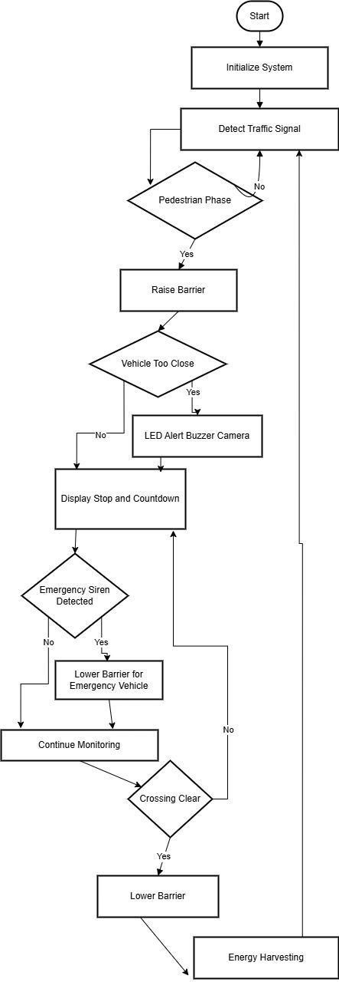

- Description of the invention in detail (Include drawing and or photograph as needed) Block Diagram:
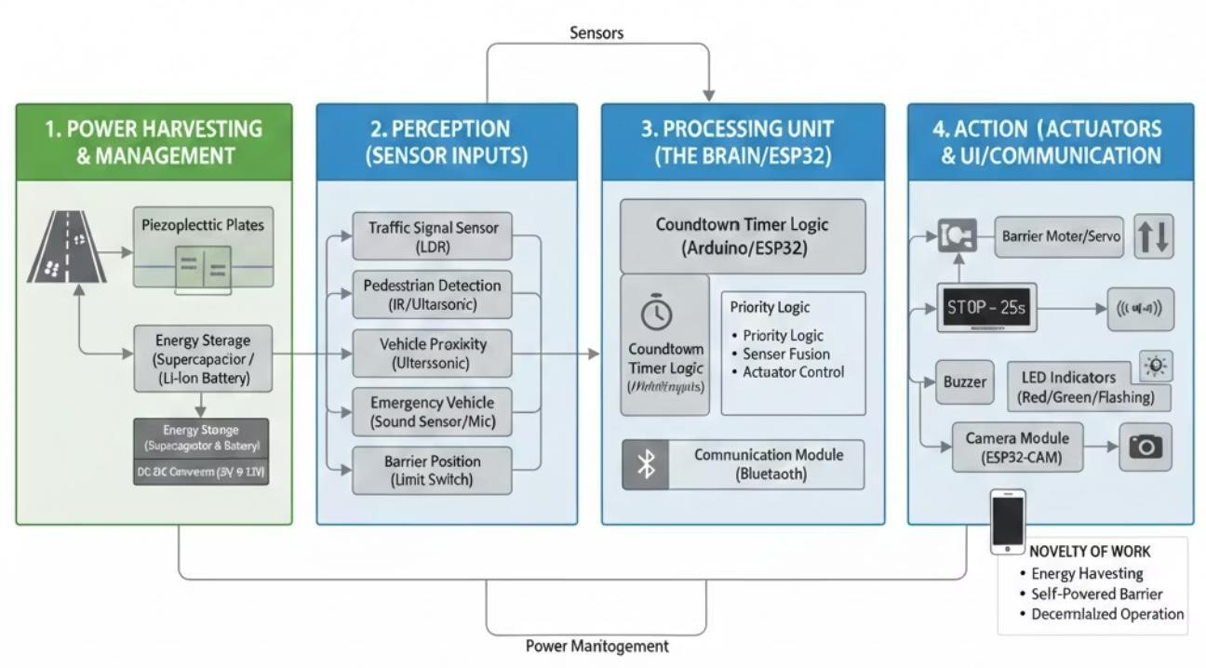

The system combines hardware, sensors, actuators, energy harvesting modules, and control logic to identify pedestrian and vehicle traffic, control traffic barriers, and issue real-time alerts
Hardware Components
- Microcontroller: Arduino/ESP32 for processing sensor inputs and controlling actuators.
- Sensors:
  - IR sensor → Detects the presence of a person near the crossing area. Sends signal to close the barrier and ensure pedestrian safety.
  - Ultrasonic sensor → Measures distance of approaching vehicles using sound waves. Triggers alerts or barrier control when a vehicle is too close.
  - Sound sensor → Detects high-frequency sounds like ambulance sirens. Gives priority to emergency vehicles by opening the barrier immediately.
  - Limit switch → Detects whether the barrier is fully open or fully closed. Prevents over- rotation of the motor and ensures accurate positioning.
  - Piezoelectric sensors → Detects whether the barrier is fully open or fully closed.Prevents over-rotation of the motor and ensures accurate positioning.
- Actuators:
  - Servo/DC motor → Controls the physical movement of the barrier (open/close).Operates based on signals from the microcontroller.
  - Relay / Motor driver → Acts as a switch to control high-power devices like motors.Protects the microcontroller by handling higher voltage/current loads.
- Output Devices:
  - LCD display → Displays system messages .Provides real-time feedback to users at the crossing.
  - Buzzer → Produces sound alerts for warnings (e.g., vehicle too close). Enhances safety by giving audible notifications.

- Energy Harvesting & Storage:
  - Piezoelectric plates → Generate electrical energy from pressure(mechanical energy) caused by vehicles. Acts as a renewable energy source for the system.
  - Bridge rectifier & capacitor → Converts AC output from piezo sensors into usable DC voltage. Capacitor smooths fluctuations and stabilizes the output.
  - Supercapacitor / Li-ion battery → Stores harvested energy for later use. Provides backup power when main supply is unavailable.

Software Logic
- Sensors are read by the microcontroller and barrier control logic for safety is administered.
- Internal timers and software counters control pedestrian crossing countdown, elapsed time for task completion, as well as an alarm timer. There is also an emergency vehicle detection that allows autosaving of barrier for barrier override.
- Energy management software allows for stable operation using stored harvested energy.

CODE:
#include <Wire.h>
#include <LiquidCrystal_I2C.h> #include <Servo.h>

// I2C address 0x27 is standard for JHD 162A LiquidCrystal_I2C lcd(0x27, 16, 2);
Servo gateServo;

// Pin Definitions const int irSensor = 2;
const int soundSensor = 4; const int trigPin = 6; const int echoPin = 7; const int buzzer = 8; const int servoPin = 9;

// Timer for Siren
unsigned long sirenStartTime = 0; const long sirenHoldTime = 5000; void setup() {
pinMode(irSensor, INPUT); pinMode(soundSensor, INPUT); pinMode(trigPin, OUTPUT); pinMode(echoPin, INPUT); pinMode(buzzer, OUTPUT); gateServo.attach(servoPin); lcd.init();
lcd.backlight(); gateServo.write(0); // Start Open
}
void loop() {
// 1. Get Ultrasonic Distance long duration;
int distance; digitalWrite(trigPin, LOW); delayMicroseconds(2); digitalWrite(trigPin, HIGH); delayMicroseconds(10);

digitalWrite(trigPin, LOW); duration = pulseIn(echoPin, HIGH); distance = duration * 0.034 / 2;

// 2. Read Sensors
int personDetected = digitalRead(irSensor); int sirenDetected = digitalRead(soundSensor);
// Update siren timer if sound is heard if (sirenDetected == HIGH) { sirenStartTime = millis();
}
lcd.clear();
// 3. LOGIC HIERARCHY
// PRIORITY 1: AMBULANCE (Master Override) if (millis() - sirenStartTime < sirenHoldTime) { gateServo.write(0); // OPEN for ambulance lcd.setCursor(0, 0);
lcd.print("AMBULANCE ON THE");
lcd.setCursor(0, 1); lcd.print("WAY! MAKE WAY");
}
// PRIORITY 2: PEDESTRIAN DETECTION (Person is present) else if (personDetected == LOW) {
gateServo.write(90); // CLOSE for cars lcd.setCursor(0, 0);
lcd.print("STOP! PEDESTRIAN");
lcd.setCursor(0, 1); lcd.print("CROSSING");
}
// PRIORITY 3: VEHICLE PROXIMITY ALERT
else if (distance > 0 && distance < 10) { gateServo.write(0);
lcd.setCursor(0, 0); lcd.print("YOU ARE TOO"); lcd.setCursor(0, 1);
lcd.print("CLOSE TO BARRIER");
}
// DEFAULT: ROAD CLEAR
else {
gateServo.write(0); // OPEN for cars lcd.setCursor(0, 0); lcd.print("ROAD IS CLEAR");
}
// 4. BUZZER CONTROL (Independent safety beep) if (distance > 0 && distance < 10) { digitalWrite(buzzer, HIGH);
} else {
digitalWrite(buzzer, LOW);
}
delay(200);
}

System Operation
- Barrier was ready to lift once the change of traffic signals has been distinguished.
- The Barrier was completely lowered when the pedestrian has been detected allowing pedestrian to cross safely.
- System was powered all the time with self-sufficient system through energy harvester.
- Barrier lowered automatically for the emergency siren if detected.
- Countdown timer was displayed to guide pedestrians and barrier was synchronized.

Experimental validation results:

The system was built as a prototype and experiments conducted to evaluate its real-time operation by simulating some traffic scenarios. Through this it was decided whether the various sensors and the alert mechanisms shown were very good or need to be improved. It was also checked whether the energy harvesting unit was being successful and demonstrating the efficiency.

Prototype Testing
A small prototype had been built with the microcontroller,the different sensors, a barrier which responded to the motor and the output devices. Various test scenarios were conducted to validate system performance.

Test Case 1 : Pedestrian Detection
The IR / ultrasonic sensors were used to check if the sensors can detect when a person is coming close to the crossing area. All the sensors were working and on detection of a person the barrier was lowered and the time captured by the timer was given as the countdown so that the pedestrian knows when to cross the road safely.
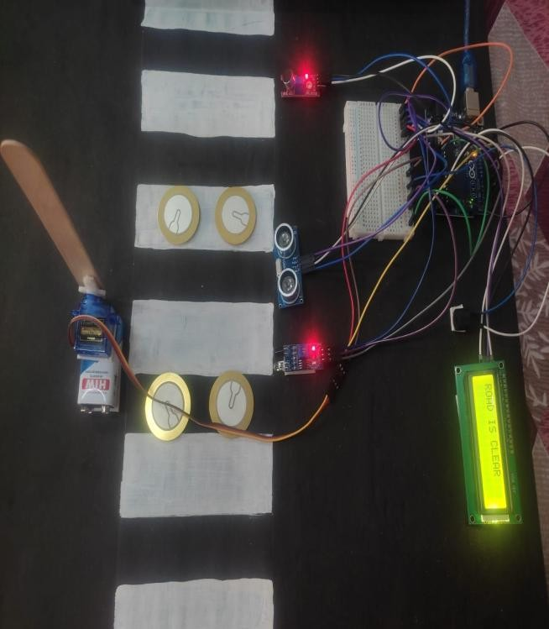
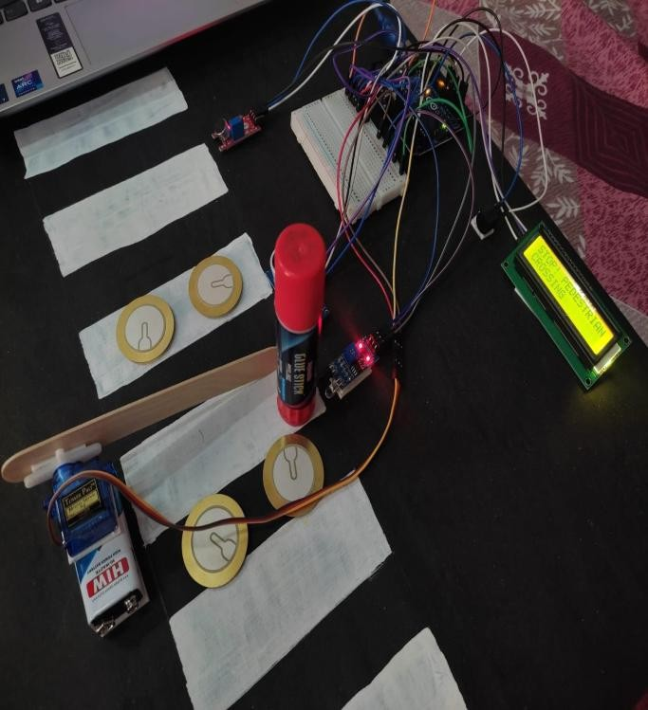

Test Case 2: Vehicle Proximity Detection
The ultrasonic sensor was checking the covered the distance of approaching vehicles. When a vehicle was detected to be getting too close to the crossing area during a pedestrian phase, all the output devices were working to give loud horns and display warnings.
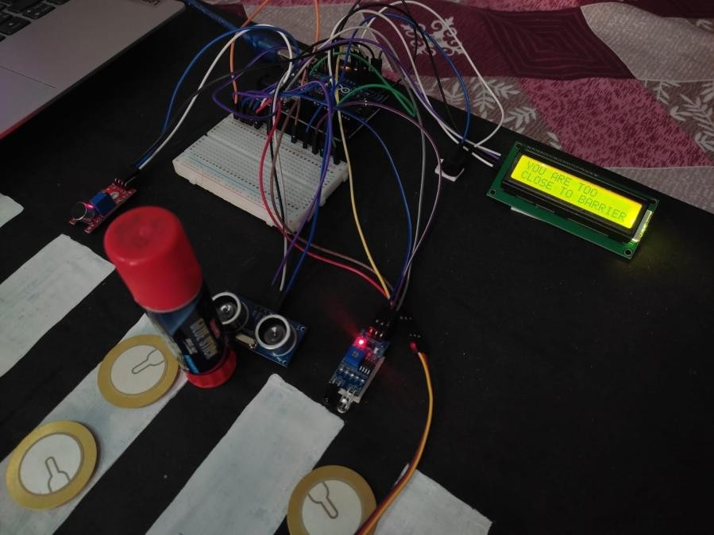

Test Case 3: Emergency Vehicle Detection
The sound sensors detected the emergency vehicle honk and when the system was tested, the barrier was lowered and restriction of the system was set to OFF so that the vehicle could cross easily.
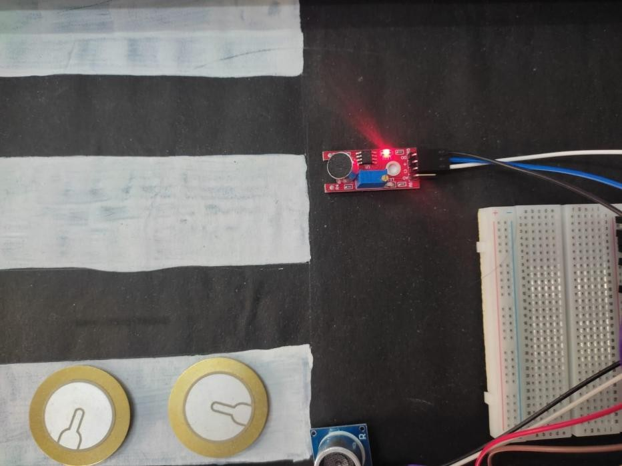

Test Case 4: Energy Harvesting Validation
When a person pushed pressure on the piezoelectric plates they produced small electricity. The electricity produced was done to the rectifier and was stored in the capacitor / battery system to check whether the system self-powered or not.
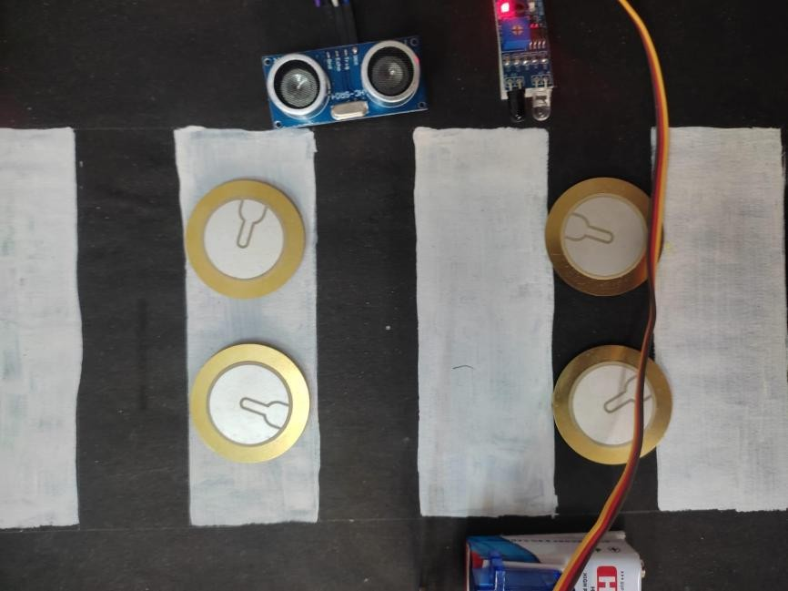

Results and Observations
The experimental tests were able to validate that:
- The sensors were able to detect the traffic signals, pedestrians, and approaching vehicles.
- The automated barrier system was able to respond correctly to the control signals.
- The visual and audio alert systems were able to alert the vehicles and pedestrians.
- The emergency vehicle detection was able to trigger the override.
- The piezoelectric energy harvesting module was able to generate electricity.
In conclusion, the prototype was able to validate the proposed system, which would be able to improve the safety of the pedestrians and the overall efficiency of the traffic management.
Overall, the prototype demonstrated that the proposed system can enhance pedestrian safety and improve traffic management efficiency when implemented in real-world environments.

What aspect(s) of the invention need(s) protection?

The following aspects of the invention need protection due to their novelty and practical significance:
- Integrated Self-Powered Pedestrian Safety System, a unit that combines energy harvesting and detection and dynamic barrier control.
- Energy Harvesting Zebra Crossing Mechanism that employs piezoelectric sensors in harnessing electrical energy on the footsteps of people and moving vehicles to power safety devices.
- Dynamic Motorized Barrier Control Logic, that limits the movement of vehicles according to the presence of pedestrians, the state of the traffic signal and the proximity of the vehicle.
- Emergency Vehicle Siren-Based Override Mechanism, to automatically override the barrier control, after the detection of sirens belonging to emergency vehicles in order to allow the free movement of the traffic.
- Multi-Sensor Synchronization and Control Architecture, which allows the synchronization and control of safety devices without a server or internet connection.
- A decentralized standalone operation model which is designed to operate reliably in infrastructurally challenged environments.

 Invention Disclosure Format (IDF)-B | Document No. | 02-IPR-R003
 | Issue No/Date | 2/01.02.2024
 | Amd. No/Date | 0/00.00.0000

- What is Technology readiness level of your invention? (Tick the appropriate TRL)

Research |  |  | Development |  |  | Deployment
TRL 1 | TRL 2 | TRL 3 | TRL 4 | TRL 5 | TRL 6 | TRL 7 | TRL 8 | TRL 9
Basic | Technology | Experimental | Technology | Technology | Technology | System | System | Actual system
Principles | concept | proof of | validated in | validated in a | demonstrated | prototype | complete | proven in an
observed | formulated | concept | a lab | relevant | in a relevant | demonstration | and | operational
 |  |  |  | environment | environment | in an | qualified | environment
 |  |  |  | (industrially | (industrially | operational |  | (competitive
 |  |  |  | relevant in | relevant in | environment |  | manufacturing
 |  |  |  | case of key | case of key |  |  | in case of key
 |  |  |  | enabling | enabling |  |  | enabling
 |  |  |  | technologies) | technologies) |  |  | technologies,
 |  |  |  |  |  |  |  | or in space )
 |  |  | ✔

----------------------END OF THE DOCUMENT-----------------------------

